Abdurrahman Mohammad

Ying Chang Cui

Eduardo Fragoso

Emmanuel Cestoni

**Analysis Phase**

Voicemail System

**-------------------- Functional Specification --------------------**

Summary:

This is a voicemail system that does:

* Lets a person dial an extension number. An input line consisting of a single character 1 . . . 9 denotes a pressed button on the telephone touchpad
* Connects the call to the extension
* Provided the other party does not pick up the telephone, the caller leaves a message
* The other party can later retrieve and listen to the messages
* The other party can later keep the messages
* The other party can later delete the messages
* The administrator should be able to add multiple users to the system, each with their personal mailbox, password and extension number.
* The administrator should be able to set, reset and change all the users’ passwords.

Point of view of the caller:

The caller has the options to:

* When the caller calls the main number, he will be asked to dial an extension or hang-up
* The caller dials an extension and is connected to that extensions
* If the owner of the extension does not pickup, the caller will be directed to voicemail
* A greeting is played which is recorded and set by the extension owner
  + The owner records 3 greetings and sets one among them to the default greeting
* The caller can then hang-up or leave a 30 second message.

Point of view of the owner:

* The owner calls the main number and dials his extension
* He will be asked to enter a password or wait to leave a message
* He will enter the correct password. If it is incorrect, he repeats the above steps
* The owner then would have the option to manage messages or manage the greeting
* The owner now can view unread messages or read messages
* Then the messages in the queue of the unread then read messages are played. He will have the option to delete the played message or keep them immediately after each one is played.
* After reading an unread message, it will be stored in the read messages queue
* Then the owner may hang-up after any message is played by pressing ‘Hang Up’ or he may listen to all the messages in the selected queue before the system hangs up.
* If the owner presses the button to manage the greetings, he will have the option to add a greeting, remove a greeting, change the default greeting, or listen to a greeting
* If the owner selects to record a greeting, he will then enter a number 0, 1, or 2 and record a greeting. This will replace the selected (numbered) greeting with the recorded one.
* If the owner selects to change the default greeting, he will enter a number 0, 1 or 2 which will set the default greeting to one of the recorded greetings

Point of view of the administrator:

* The admin calls the main number and dials the extension ‘000’
* He will be asked to enter a password or wait to leave a message. The password comes in the box. The password may be ‘789’.
* He will enter the correct password. If it is incorrect, he repeats the above steps
* He will be played a welcome message and will listen to the options available
* The admin can then enter an extension to edit
* Then the admin can enable (add) the extension or disable (remove) the extension or change its password
* When the admin creates an extension, he will have the option to set the password. If the admin hangs up before entering the password, the mailbox is not created.

**-------------------- User Manual --------------------**

**For the administrator**

To access the administrator menu:

1. Dial the main number of the voicemail system on your telephone
2. Listen to the greeting: “Welcome. Please enter the extension you are trying to reach”
3. You will be prompted to enter an extension. Enter the extension ‘000’. This will lead to the administrator menu. You will hear, “Welcome to the administrator menu. Please enter the password”
4. Enter the password of the administrator menu. This is the password that comes in the box. An example is ‘789’
5. If you enter the wrong password, you will be disconnected. If you enter the correct password, you will be hear a greeting and your options, “Welcome to the administrator menu. Please enter the extension of the mailbox you wish to edit”
6. Enter the extension of the mailbox to edit. If it is a valid extension in the range of 001 to 999, you will hear your options, “To add this mailbox, enter 1. To delete this mailbox, enter 2, to change its password enter 3. To reset the system, press 4.” Invalid input will lead to disconnection

How to add a mailbox extension to the voicemail system:

1. Follow the steps to access the administrator menu and enter 1 in the last step
2. You will be prompted to enter an extension number and a password
3. After entering the two set of numbers, you will be notified if the mailbox was created

How to remove a mailbox extension from the voicemail system:

1. Follow the steps to access the administrator menu and enter 2 in the last step
2. Enter the extension of the mailbox to delete
3. You will hear, “This mailbox has successfully been deleted. Goodbye!” and hang up

How to change the password of a mailbox in the voicemail system:

1. Follow the steps to access the administrator menu and enter 3 in the last step
2. You will be prompted for a password, “Please enter a password for this mailbox”
3. After entering the password, you will be notified if the password was changed

How to reset the system:

1. Follow the steps to access the administrator menu and enter 4 in the last step
2. You will be played a message mentioning the system was reset and all mailboxes were deleted

**For the caller**

How to call an extension:

1. Dial the main number of the voicemail system on your telephone
2. Listen to the greeting: “Welcome. Please enter the extension you are trying to reach”
3. Enter the extension you are trying to reach. You will then be connected to that extension
4. If the owner is present and picks up the phone, you will be able to speak with the owner
5. After the call, you may hang up anytime

How to leave a message:

1. Dial the main number of the voicemail system on your telephone
2. Listen to the greeting: “Welcome. Please enter the extension you are trying to reach”
3. Enter the extension you are trying to reach. You will then be connected to that extension
4. If the owner is not present to pick up the phone, you will be directed to voicemail. Press 1 to leave a message when prompted. You will hear a greeting set by the owner of the mailbox.
5. You will then be prompted to leave a short message and then will be disconnected

**For the mailbox owner**

How to access the mailbox menu:

1. Dial the main number of the voicemail system on your telephone
2. Listen to the greeting: “Welcome. Please enter the extension you are trying to reach”
3. Enter your extension number. You will then be connected to that extension. You will then hear your default greeting
4. Then enter the password associated with the mailbox set by the administrator. If it is correct, you will hear, “Welcome to voicemail management.” If it is incorrect, you will be disconnected and will have to repeat above steps.
5. You will then hear, “Enter 1 to manage messages, enter 2 to manage greetings”

How to listen and manage unread messages:

1. Follow the steps to access the voicemail menu and enter 1 in the last step
2. Enter 1 for unread messages
3. Your queue of unread messages will start playing. After a message is played, you will then hear, “After a message is played, enter 1 to delete. Press 2 to delete all. Enter any key to listen to the next message.”
4. Click the key corresponding to your desired action
5. After listening to all the messages, you will be hanged up

How to listen and manage saved messages:

1. Follow the steps to access the voicemail menu and enter 1 in the last step
2. Enter 2 for saved messages
3. Your queue of saved messages will start playing. After a message is played, you will then hear, “After a message is played, enter 1 to delete. Press 2 to delete all. Enter any key to listen to the next message.”
4. Click the key corresponding to your desired action
5. After listening to all the messages, you will be hanged up

How to record a greeting:

1. Follow the steps to access the voicemail menu
2. Enter 2
3. You will hear, “Welcome to greeting management. Press 0 to record a greeting. Press 1 to change the default greeting. Press 2 to listen to a recorded greeting”
4. Press 0
5. You will then hear, “Press the number of the greeting to change”
6. Enter 1 to change greeting 1, 2 to change greeting 2, and 3 to change greeting 3
7. After the “beep”, record your greeting
8. Then hang up

How to set a default greeting:

1. Follow the steps to access the voicemail menu
2. Enter 2
3. You will hear, “Welcome to greeting management. Press 0 to record a greeting. Press 1 to change the default greeting. Press 2 to listen to a recorded greeting”
4. Press 1
5. You will then hear, “Press the number of the greeting to set as default”
6. Enter 1 to change the default greeting to greeting 1, 2 to change it to greeting 2, and 3 to change it to greeting 3
7. Then you will hear, “Default greeting set”
8. Then hang up

How to listen to a recorded greeting:

1. Follow the steps to access the voicemail menu
2. Enter 2
3. You will hear, “Welcome to greeting management. Press 0 to record a greeting. Press 1 to change the default greeting. Press 2 to listen to a recorded greeting”
4. Press 2
5. You will then hear, “Press the number of the greeting to hear”
6. Enter 1 to listen to greeting 1, 2 to listen to greeting 2, and 3 to listen to greeting 3
7. Then you will hear the greeting you selected
8. Then hang up

**-------------------- Use Cases --------------------**

Main Scenario:

1. The caller calls the number of the system from the “main” worldwide telephone system
2. Listen to the greeting: “Welcome. Please enter the extension you are trying to reach”
3. Enter your extension number. You will then be connected to that extension.

Invalid input for extension number:

* + If the caller enters an invalid input (any symbols or H), he will be disconnected

Invalid extension number:

* + If the entered extension is invalid, the caller will be disconnected

Valid input for extension number:

1. Add a mailbox

Actor: administrator

Description: Activate a mailbox in the voicemail system

* + Follow the above steps and dial the extension ‘000’. You will be connected to the administrator menu
  + Enter the password of the administrator menu. This is the password that comes in the box. An example is ‘789

Invalid input:

* + If you enter a symbol or H, you will be disconnected

Invalid password:

* + If you enter the incorrect password, you will be disconnected

Valid password:

* + You should then enter the extension of the mailbox to manage

Invalid mailbox extension:

* + If you enter symbols or H or a number not in the range of the extensions 001 to 999, you will be disconnected

Valid extension:

* + Then you press 0 to add this mailbox

Invalid input

* + You will be disconnected

Valid input

* + The mailbox will be added and you will be prompted to enter a password

Invalid password:

* + If you enter any symbols or H, you will be disconnected and the password will be ‘000’

Valid password:

* + If you enter a valid password, the password will be changed and you will be disconnected

1. Delete a mailbox

Actor: administrator

Description: Deactivate a mailbox in the voicemail system

* + Follow the above steps and dial the extension ‘000’. You will be connected to the administrator menu
  + Enter the password of the administrator menu. This is the password that comes in the box. An example is ‘789’

Invalid input:

* + If you enter a symbol or H, you will be disconnected

Invalid password:

* + If you enter the incorrect password, you will be disconnected

Valid password:

* + You should then enter the extension of the mailbox to manage

Invalid mailbox extension:

* + If you enter symbols or H or a number not in the range of the extensions 001 to 999, you will be disconnected

Valid extension:

* + Then you press 1 to delete this mailbox

Invalid input

* + You will be disconnected if you enter anything else

Valid input

* + The mailbox will be deleted and you will be disconnected

1. Set a mailbox password

Actor: administrator

Description: Set a mailbox password

* + Follow the above steps and dial the extension ‘000’. You will be connected to the administrator menu
  + Enter the password of the administrator menu. This is the password that comes in the box. An example is ‘789’

Invalid input:

* + If you enter a symbol or H, you will be disconnected

Invalid password:

* + If you enter the incorrect password, you will be disconnected

Valid password:

* + You should then enter the extension of the mailbox to manage

Invalid mailbox extension:

* + If you enter symbols or H or a number not in the range of the extensions 001 to 999, you will be disconnected

Valid extension:

* + Then you press 2 to change this mailbox’s password

Invalid input

* + You will be disconnected if you press anything else

Valid input

* + You will be prompted to enter a password

Invalid password:

* + You will be disconnected if you enter symbols or H and the password would be ‘000’

Valid password:

* + If you enter a valid password, the password will be changed and you will be disconnected

1. Call an extension

Actor: caller

Description: Set a mailbox password

* + Follow the steps in main and enter a valid extension
  + You will be automatically connected to the extension. If the owner is present, you can speak to him and hang up. If not, you can leave a message.

1. Leave a message

Actor: caller

Description: Set a mailbox password

* + Follow the steps in main and enter a valid extension
  + You will be automatically connected to the extension. If the owner is not present, you will be played a greeting and will be asked to wait or enter any 3 keys
  + Enter H:
  + You will be disconnected
  + Enter any 3 keys or wait:
  + A “beep” will be played and you will have 30 seconds to leave a message or you can press H anytime to hang up. After 30 seconds, you will be hanged up.

1. Listen to and manage read or unread messages

Actor: Mailbox owner

Description: Listen to and delete unread messages

* + Follow the steps in main and enter a valid extension
  + You will be automatically connected to the extension. You should now enter the password associated with the mailbox
  + Invalid input:
  + You will be disconnected
  + Invalid password:
  + You can leave a message to yourself or hang up
  + Correct password:
  + You can press 0 to listen to the unread messages and 1 to listen to the read messages

Invalid input:

* + Entering anything else will lead to disconnection aside from 2 (covered later)

Valid input:

* + The selected message queue will be played. Press 1 after a message is played to delete it

Invalid input:

* + Entering H will disconnect

Valid Input:

* + Pressing 1 will delete. Pressing any other key aside from H will play the next messages. After all the messages are played, you will be disconnected

1. Manage the mailbox greetings

Actor: Mailbox owner

Description: Record greeting, set default greeting, listen to greeting

* + Follow the steps in main and enter a valid extension
  + You will be automatically connected to the extension. You should now enter the password associated with the mailbox
  + Invalid input:
  + You will be disconnected
  + Invalid password:
  + You can leave a message to yourself or hang up
  + Correct password:
  + You should enter 2 to manage greetings

Invalid input:

* + Entering anything else will lead to disconnection aside from 0 and 1 (previous)

Valid input:

* + You can then enter 0 to record greeting, 1 to set default greeting, and 2 to listen to a greeting

Invalid input:

* + You will be disconnected

Record greeting:

* + You will then enter a number 1, 2, or 3 and then record a greeting. Any other input will hang up.  
    Set default greeting:
  + You will enter 1, 2, or 3 to set the default greeting. Any other input will hang up.

Listen to a greeting:

* + You will then enter 1, 2, or 3 to listen to a recorded greeting. Any other input will hang up

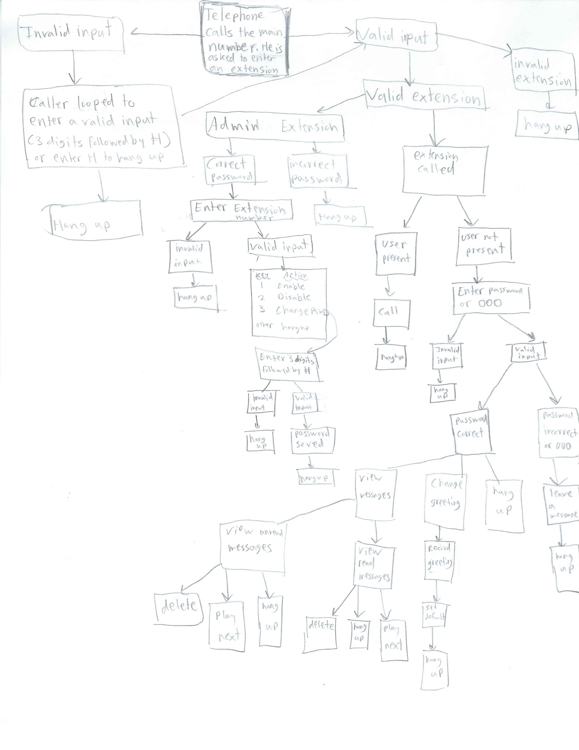

Use Cases as a summary:

The caller calls the number of the system from the “main” worldwide telephone system

(method). The system would start playing the caller’s options and wait for an input. **Use Case: Invalid input**

If the input is invalid (letters, symbols, length larger than 3), the system would ask for another input or ask to enter H to hang-up. If the input is a symbol that is not a number, ‘H’, or ‘#’, you will be asked to reenter.

**Use Case: Valid input**

After a valid input (3 numbers followed by ‘#), the system would then search and connect the caller to the correct extension and call it. The user may pick up the phone and the system hangs-up after the call. You can press ‘H’ to hangup.

**Use Case: Admin Menu**

If the user dials ‘000’ and enters the correct password (eg. ‘789’), he will have the option to enable or disable mailboxes and change their passwords. The admin then enters an extension to manage it. Then he can press 0 to enable, press 1 to disable, or 2 to change the password of the selected extension.

**Use Case: The extension owner is not available to pickup**

If the extension is not ‘000’ and the owner is not available to pick up the call, the caller would be led to voicemail. A greeting will be played recorded by the owner. Then the caller will hear more options, such as to enter a password or wait for the “beep” to leave a message. These two cases will be discussed in the following paragraphs.

**Use Case: The user enters the correct password – voicemail management**

If the user enters a password, he will be played a message stating his options. Press 0 to manage messages or 1 to manage greetings. If you press 1 to manage messages, you will have the options to: press 0 to listen to unread messages and press 1 to listen to saved/read messages. After pressing 0 or 1, you will hear: press 0 to delete a message or do nothing to keep it, press H to hang-up. After this intro message is played, the user can enter 0, H, or nothing after each message in the mailbox is played to perform an action. A message will be played, and the user will press 0 to delete the message or wait or press a random key for the next message. An unread message heard will be placed in the read messages queue. The system automatically hangs-up after playing all the messages in the mailbox.

**Use Case: Greeting management**

If the user presses 1 after entering the password, he can record a greeting (press 0), set a default greeting (press 1), or listen to a greeting (press 2). If he wants to change a greeting, he will be asked which greeting he wants to change (greeting 1, greeting 2, or greeting 3). He can press 1, 2, or 3 and then he can replace that stored greeting by speaking into the phone. If he wants to change the default greeting, the user will be asked which greeting to set as default to which the user enters 1, 2, or 3. Pressing any other keys during this phase will hang up the phone. If the user wishes to listen to a greeting, he can press 1, 2, or 3 and that greeting will be played.

**Use Case: The user enters a wrong password or waits – leave a message**

If the user enters a wrong password or does not enter anything, he will be allowed to leave a message in the mailbox. A “beep” will be played. The caller has 30 seconds to leave a message. The caller can press H during his message to end his message if he wishes not to speak for 30 seconds. If he does so, the message is ended and saved before hanging up. After leaving a message, the call is hung-up, and the system is exited.